<DOUBLY LINKED LIST>
WAP to Implement doubly link list with primitive operations: -
a) Create a doubly linked list.
b) Insert a new node to the left of the node.
c) Delete the node based on a specific value
d) Display the contents of the list
ANSWER: -
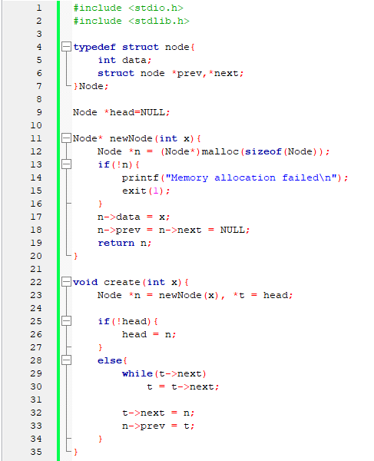
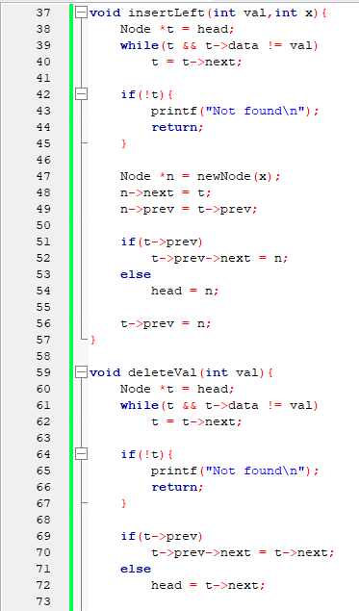
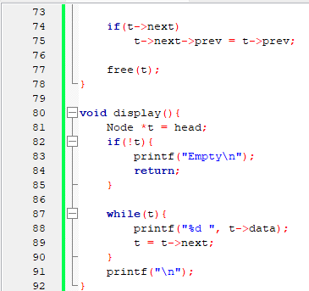
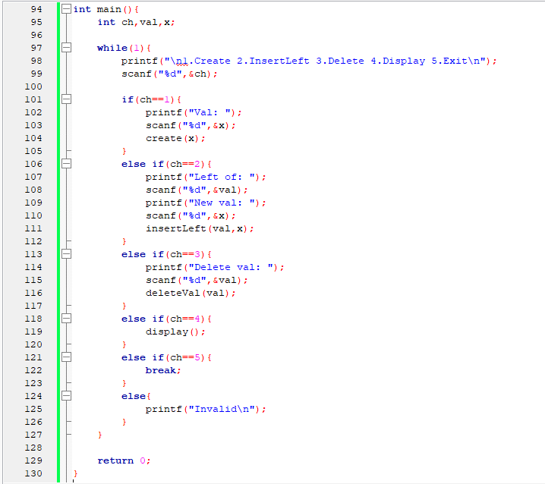

OUTPUT: -
